**ASSIGNMENT-Day 1**

**Section -1:Data**

**1. Input and output practice**

Problem statement: write a program that takes your name and age as input and prints a greeting

like: “Hello John, you are 20 years old.”

**Algorithm**

**1.Start the program**

1.Ask the user to enter their **name**

2.Ask the user to enter their **age**

3.Store both inputs

4.Print the message:

“Hello <name>, you are <age> years old.”

5.End the program

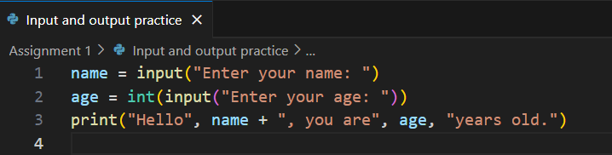**Code:**

**Output:**

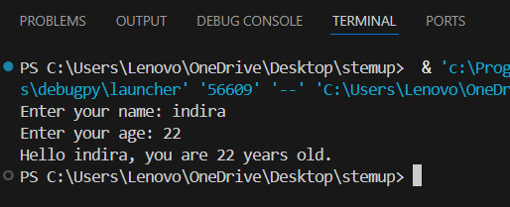

**2. Type conversion challenge**

Problem statement: take two numbers as input (strings), convert them to integers, and print their

sum, difference, and product.

**Algorithm**

1.Start the program

2.Get the **first number** as input (in string format)

3.Get the **second number** as input (also string)

4.Convert both strings to **integers** using int()

5.Calculate:

* + **Sum** = number1 + number2
  + **Difference** = number1 - number2
  + **Product** = number1 * number2

6.Print all three results

7.End the program

**Code:**

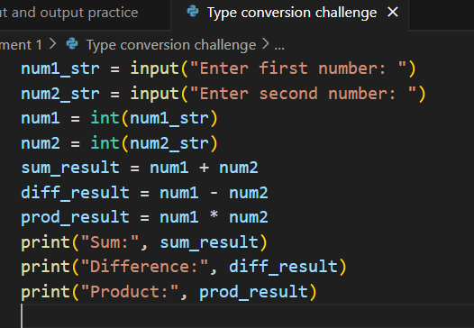

**Output:**

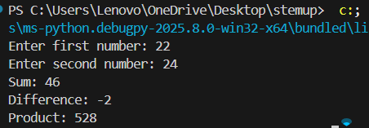

**3. Data type classification:**

Problem statement: identify the data type of the following inputs in your language of choice:

“123”, 123, 123.45, True, “Hello”

**Algorithm**

1.Define each value one by one

2.Use the built-in type() function in Python to check the data type

3.Print the result

**Code**

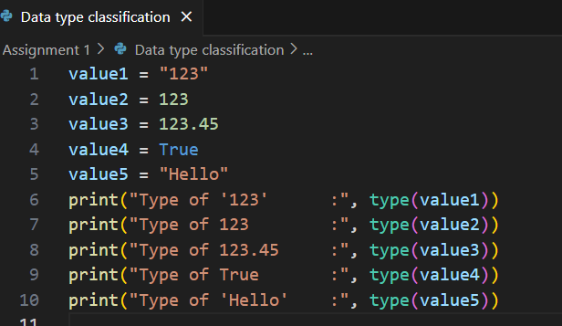

**Output:**

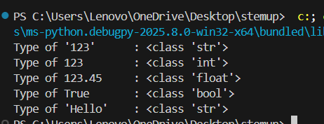

**4. Temperature Converter**

Write a program that convers Celsius to Fahrenheit using a variable and formula: F = (C * 9/5) + 32

**Algorithm:**

1. Start the program
2. Ask the user to **enter temperature in Celsius**
3. Convert the input to a **float** (decimal number)
4. Apply the formula:  
    Fahrenheit = (Celsius × 9/5) + 32
5. Print the Fahrenheit temperature
6. End the program

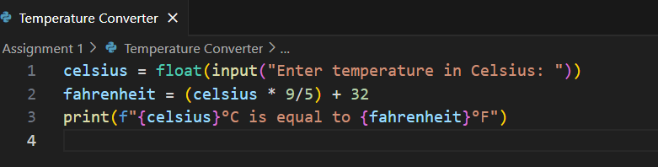**Code:**

**Output:**

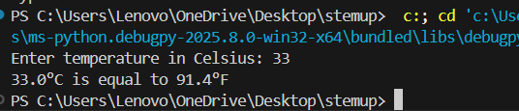

**5. Simple calculator:**

Problem statement: create a basic calculator that performs +,-,*,and / between two user provided

numbers

**Algorithm**

1. Start the program
2. Ask the user to enter the **first number**
3. Ask the user to enter the **second number**
4. Ask the user to enter the **operator** (+, -, *, or /)
5. Use if or elif to check which operation to perform
6. Perform the correct operation and display the result
7. End the program

**Code:**

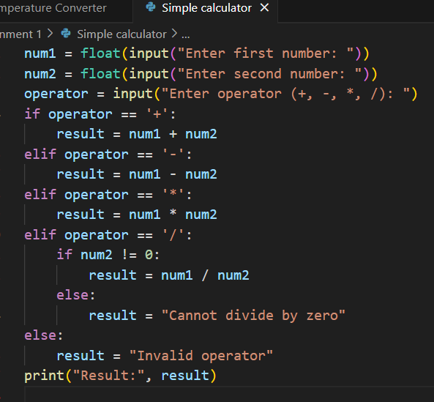

**Output:**

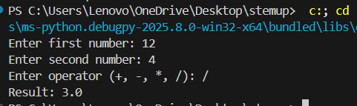

**SECTION 3: FLOW CONTROL**

**6. Even or odd checker:**

Problem statement: accept a number from the user and print whether the number is even or odd

using if else

**Algorithm**

1.Start the program

2.Ask the user to **enter a number**

3.Convert the input to an **integer**

4.Use the **modulus operator %** to check if the number is divisible by 2:

* + If number % 2 == 0, it’s **even**
  + Else, it’s **odd**

5.Print the result

6.End the program

**Code:**

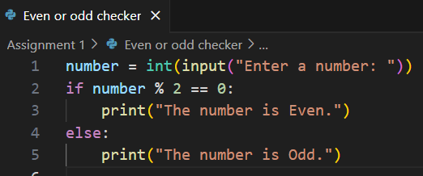

**Output:**

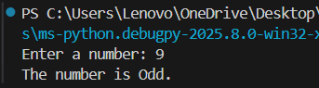

**7. Grade calculator**

Problem statement: based on marks(0-100), print grade using: A:90+ ,80-89:B, 70-79:C,60-69:D,

60-:E

**Algorithm**

1. Start the program
2. Ask the user to **enter marks**
3. Convert the input to an integer
4. Use **if-elif-else** statements to check the grade range
5. Print the appropriate grade
6. End the program

**Code:**

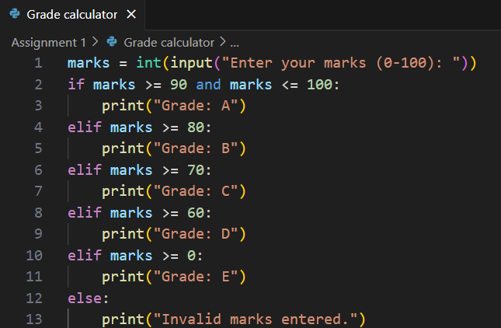

**Output:**

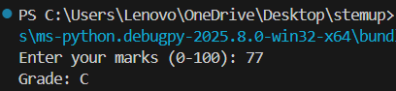

**8. Number comparison**

Problem statement: Accept two numbers and print which is greater, or if they are equal

**Algorithm**

1. Start the program
2. Ask the user to **enter the first number**
3. Ask the user to **enter the second number**
4. Convert both inputs to numbers (integers or floats)
5. Use if, elif, else to compare them:
   * If first > second → print first is greater
   * If second > first → print second is greater
   * Else → print both are equal
6. End the program

**Code:**

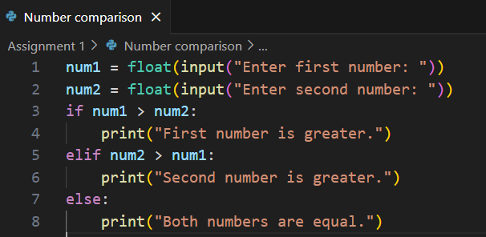

**Output:**

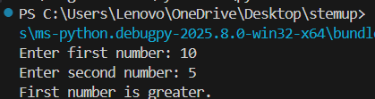

**9. Countdown time**

Problem statement: using a while loop, print numbers from 10 down to 1

**Algorithm**

1. Start the program
2. Initialize a variable num = 10
3. Use a while loop to check:
   * While num >= 1, do the following:
     + Print num
     + Decrease num by 1
4. End the loop when num < 1
5. End the program

**Code:**

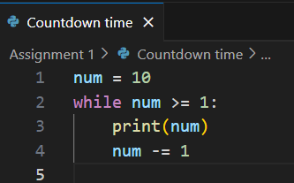

**Output:**

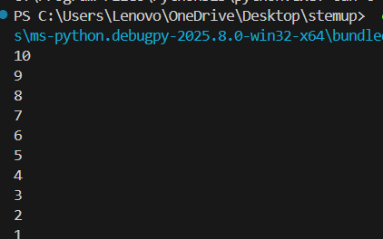

**10. Multiplication table generator:**

Problem statement: Accept a number from the user and print its multiplication table up to 10 using

a for loop

**Algorithm**

1. Start the program
2. Ask the user to **enter a number**
3. Convert the input to an **integer**
4. Use a for loop from 1 to 10
   * In each iteration, multiply the number by the loop counter
   * Print the result in the format: number x i = result
5. End the program

**Code:**

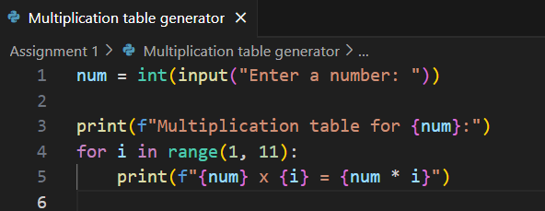

**Output:**

